Product photo  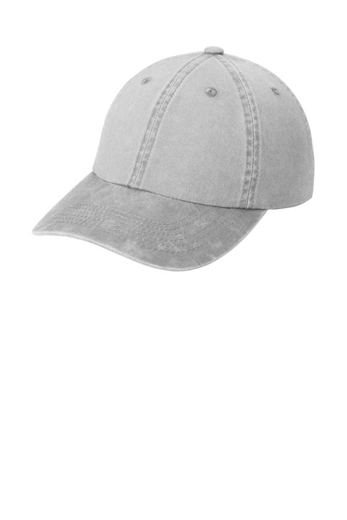 | Port Authority® Garment Washed Cap  Our popular pigment-dyed, garment washed* cap has a lived-in look and is slightly brushed for softness and comfort.  - Fabric: 100% garment washed cotton twill  - Structure: Unstructured  - Profile: Low  - Closure: Self-fabric slide closure with buckle and grommet  *Due to a special finishing process, color may vary.
Sketches
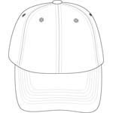  front | 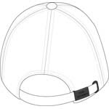  back

Product Measurements
 | OSFA
Bill/Visor Length | 2 7/8
Crown Height | 6 1/4
Width of Front Panel(s) | 7 3/8
Bill/Visor Length: Measure from outside edge of bill to crown seam at center front.
Crown Height: Measure from middle of button at top, to brim seam along center front.
Width of Front Panel(s): Measure from side seam to side seam along bottom of crown (where bill meets crown along seam).

Size Chart
 | OSFA
Hat Size | 6 5/8- 8
Head Size | 20 7/8- 25 1/8

How To Measure

Hats
Measure the circumference around the head, above the eyebrow and at the widest part of the head. Divide number by 3.14 for hat size.

